**SOFTWARE ENGINEERIG - CSA1086**

**GIT REPOSITORY CLONING**

**STEP 1: Open GitHub Repository**

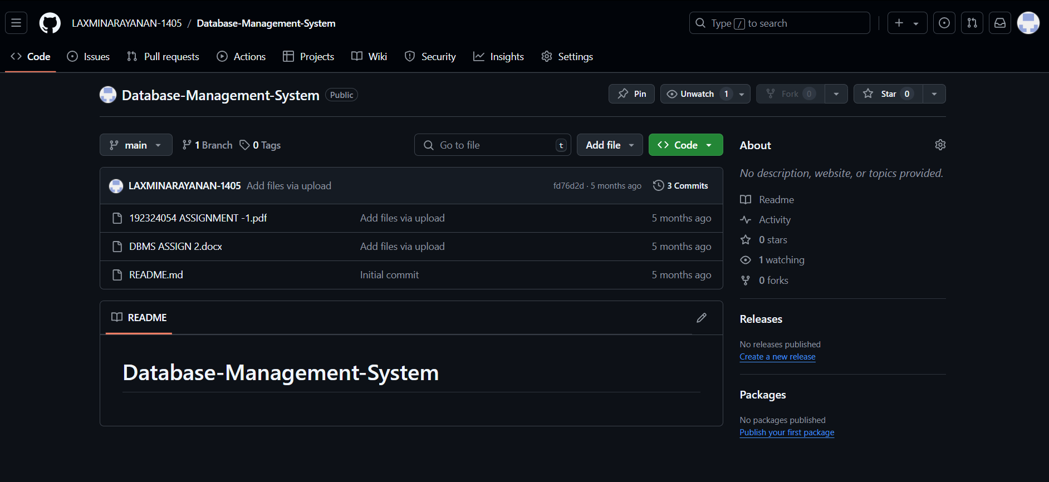

**STEP 2:. Copy the Clone URL**

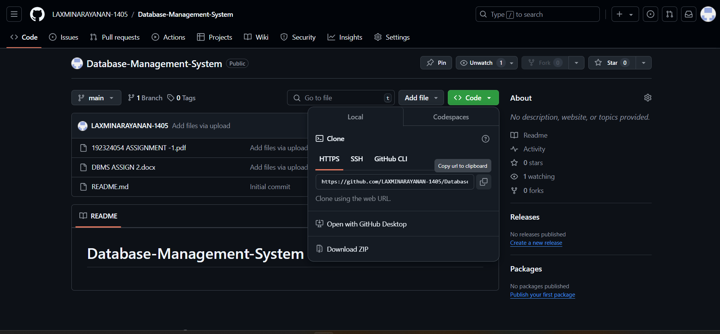

**STEP 4: Open Your Terminal/Command Prompt**

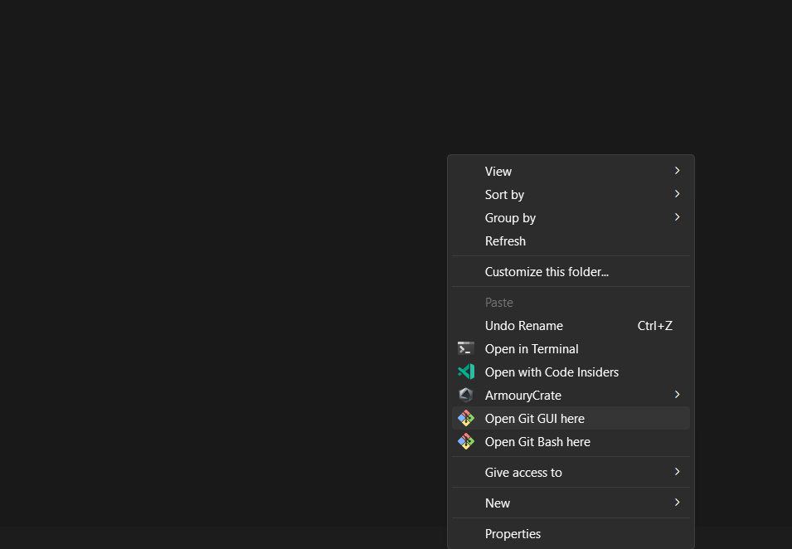

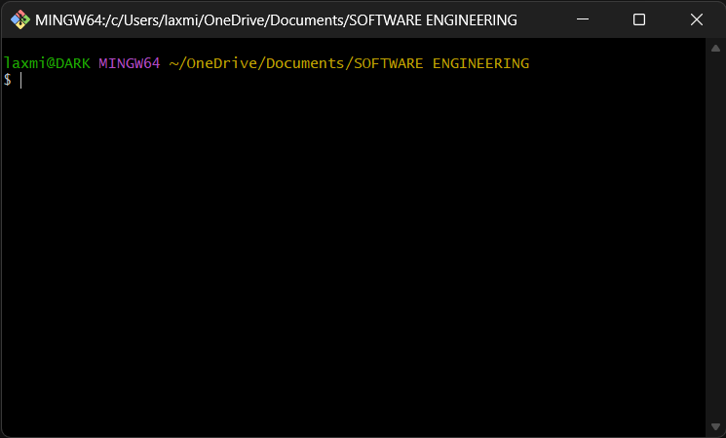

**STEP 5:Run the Clone Command**

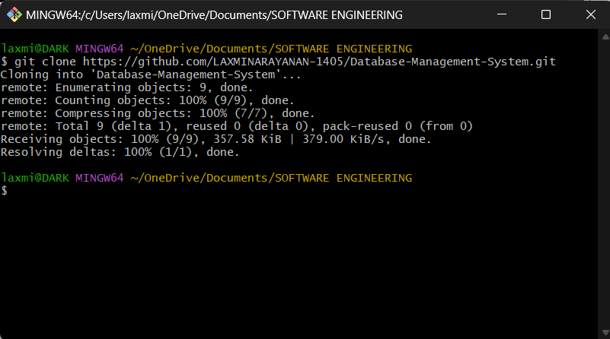

**STEP 6:Check the Repository Files**

